Fig. S1. D₂O-ESEEM spectra of n-PCSL spin-labels in DHPC at -196 °C.
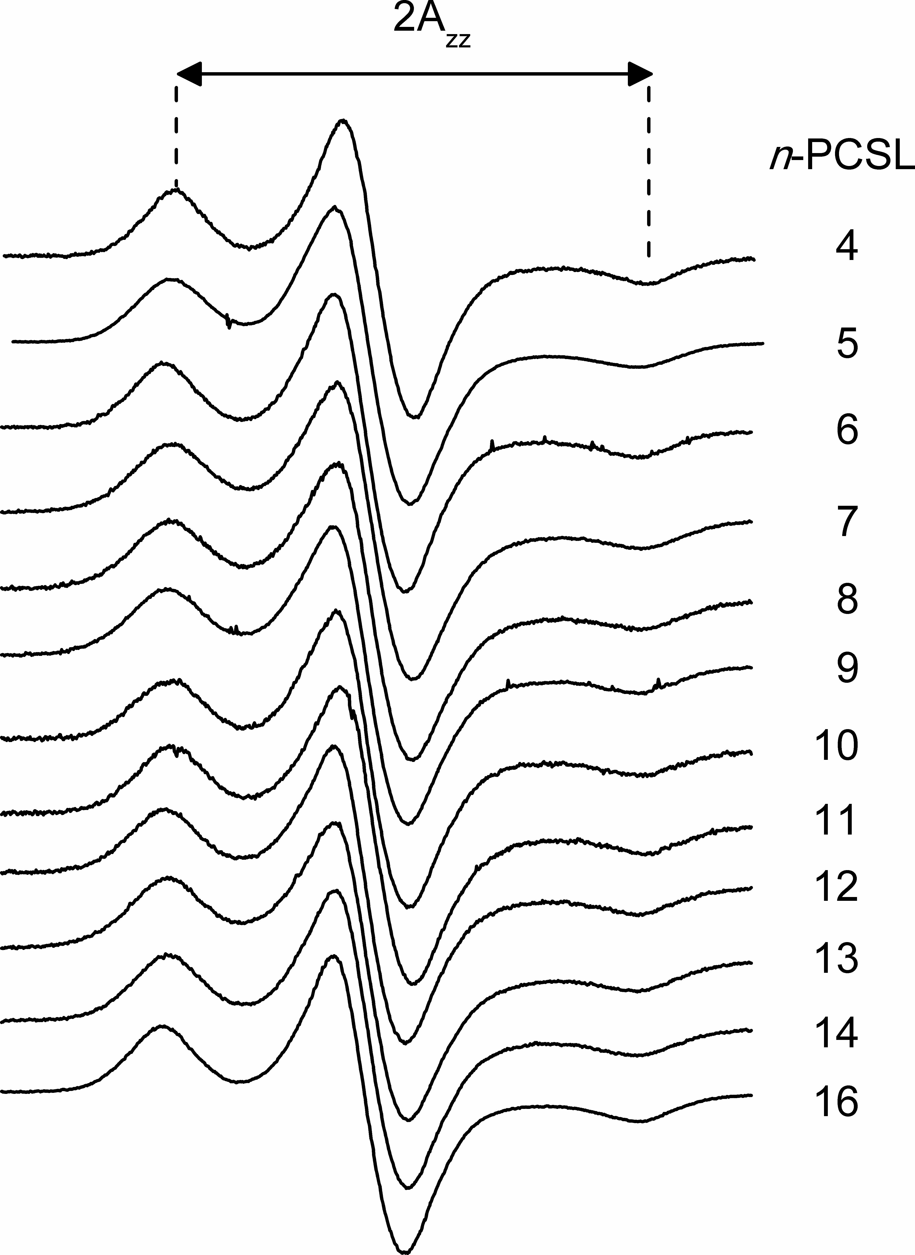

Fig. S2. CW-EPR spectra of n-PCSL spin-labels in DHPC at -196 ºC. Spectral width = 11 mT.

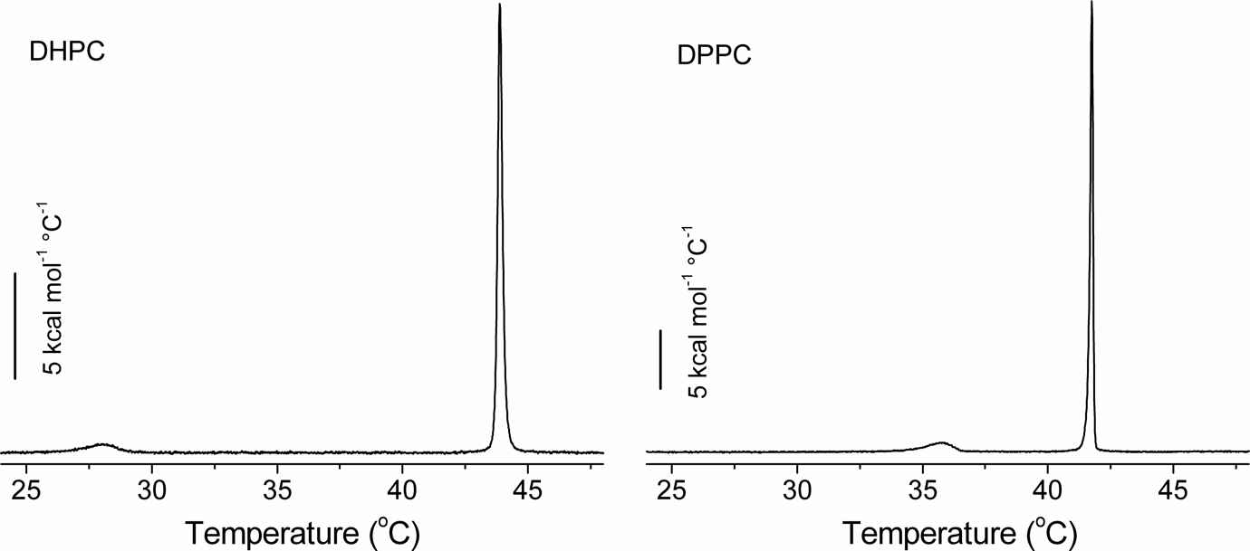

Fig. S3. DSC endotherms at a scan rate of 5 °C/h, from DHPC and DPPC dispersed in excess D₂O.

