Shell we cook it? An experimental approach to the microarchaeological record of shellfish roasting
Vera Aldeias^{1,2}, Shira Gur-Arieh³, Raquel Maria¹, Patricia Monteiro², Pedro Cura⁴
¹ Department of Human Evolution, Max Planck Institute for Evolutionary Anthropology, Leipzig, Germany
² Interdisciplinary Center for Archaeology and Evolution of Human Behavior (ICArEHB), Universidade do Algarve, Faro, Portugal
³ Max Planck Research Group on Plant Foods in Hominin Dietary Ecology, Max Planck Institute for Evolutionary Anthropology, Leipzig, Germany
⁴ Museu de Arte Pré-histórica de Mação, Mação, Portugal

Supplementary Information
1. XRD, TGA and additional FTIR analyses
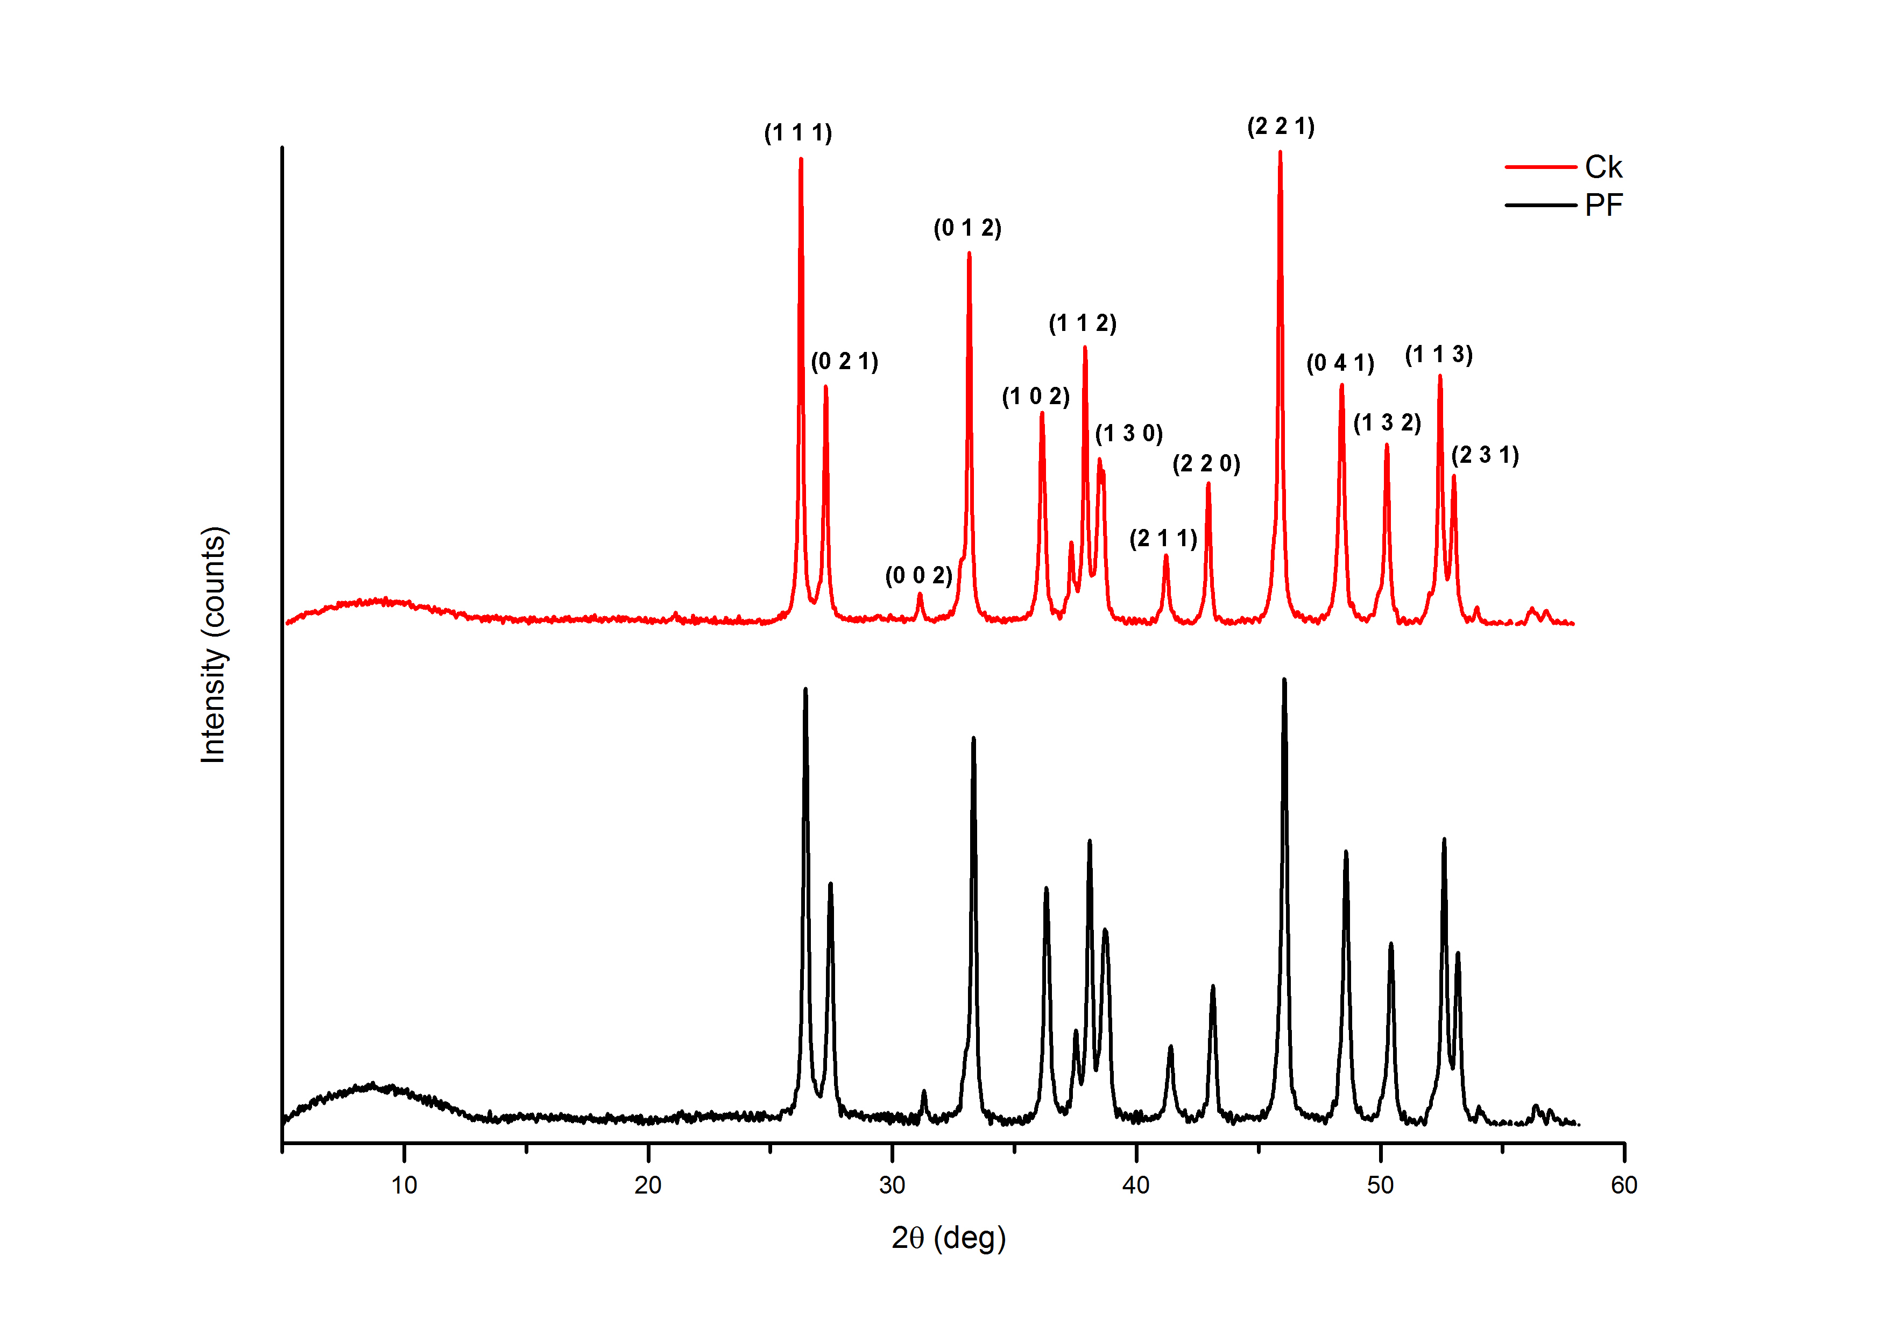
Figure S1: XRD spectra of unheated shellfish types (cockle and peppery furrow). Both unheated shells exhibit the typical aragonitic calcium carbonate (CaCO₃) diffraction pattern with the strongest characteristics peaks at 2θ values of 26.3°, 33.2°, 45.9° which correlate with (hkl) indices of (111), (012) and (221).

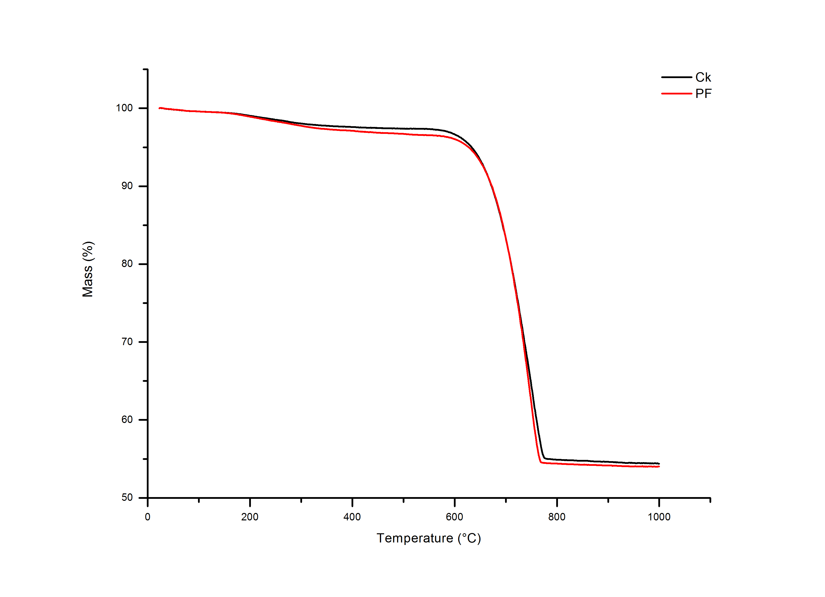
Figure S2: TGA thermogram of unheated shellfish types (cockle and peppery furrow).

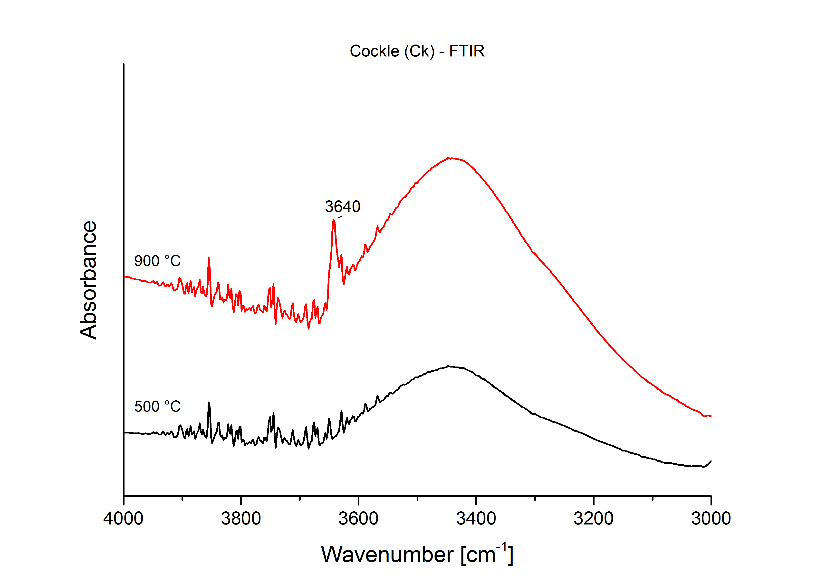
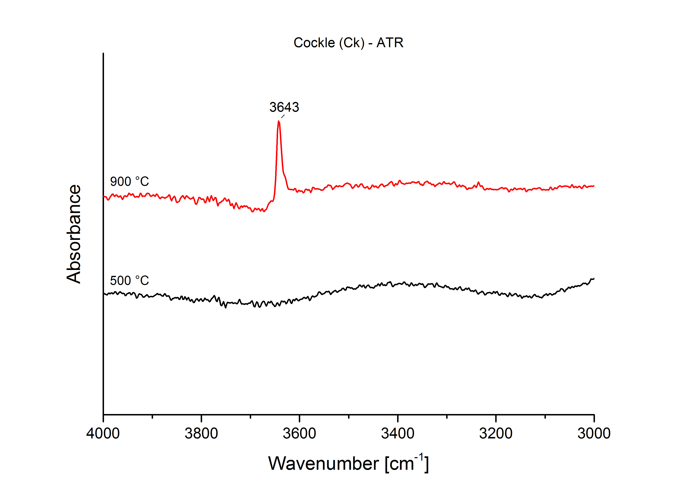
Figure S3: Detail FTIR transmission and FTIR-ATR spectra of the region 4000-3000 cm⁻¹ of shellfish type cockle.
2. Field cooking experiments – Temperature readings

3. Charcoal analyses report (by Patricia Monteiro)
Charcoal analyses allow the taxonomic identification due to the conservation of the wood anatomic cellular structure by carbonization. Observation under reflected light microscope also allows the identification of taphonomic alterations on wood charcoal cellular structure. Certain alterations observed could be related to characteristics, processes and actions towards the living tree, since its gathering to its management, through combustion process and post-deposition charcoal (Thery-Parisot et al, 2010; Euba, 2009). Ring curvature, vitrification, cracks, traumatic cells, microorganisms and mineral infiltration could provide information about the caliber (Duffraise, 2006), state and conservation of wood used for fuel (Moskal-Hoyo et al, 2010), duration and general temperatures of fire, relying to economic issues related with human management of wood acquisition modalities and production of fire.
Experimental fires provided some important information about these alterations allowing the extrapolation of data to archaeological charcoal (Thery-Parisot, 2002; Mallol et al, 2013; Chrzazvez et al, 2013).
Concerning the effects of the combustion process, the main topic from this study, in the case of wood charcoal the alterations the more common alterations observed are vitrification and cracks. vitrification is an alteration that occurs in charcoal that seems like melting cells creating and homogenous vitrified structure that usually difficult the taxonomic identification (Prior and Alvin, 1983; Thinon, 1992; Fabre, 1996; Talon, 1997; Scheel-Ybert, 1998; Gale and Cutler, 2000; Pye and Ancel, 2006; Braadbaart et al, 2009; MacParland et al, 2010). This alteration is related with the combustion, but the reason of its occurrence is still unclear. Several issues used to be associated with vitrification like resinous species (Talon, 1997; Scheel-Ybert, 1998; Pye e Ancel, 2006; MacParland, 2010), high temperatures (Prior and Alvin, 1983; Thinon, 1992; Fabre, 1996; Gale y Cutler, 2000; Braadbaart et al, 2009; Braadbaart et al, 2012; MacParland, 2010), and green wood (MacParland et al, 2010) but current studies, some of them in experimental archaeology, showed some weak correlation between these hypotheses, once this occurrence tend to be random or persistent in different variables (McParland et al, 2010). Cracks are alterations that occur during the combustion process, according to some authors at high temperatures (Thery-Parisot, 2001; Braadbaart and Poole, 2008; Chrzavzez et al, 2014), but they are also associated with the state of the wood; depending on its frequency and dimensions it is possible to tell if it is mature or green wood (Thery-Parisot and Henry, 2012).
In the particular case of our experiments it will be interesting to observe the alterations on wood charcoal resulting from different cooking techniques and temperature exposure, in order to understand their occurrence, and to compare then, with archaeological samples.
Results
Exp. # | Sample | Taxonomic ID | Combustion alterations
 |  |  | Vitrification | Cracks
C1 | SE_P1_Botanic.1 | Pinus pinaster |  | Present
 | SE_P1_Botanic.2 | Pinus pinaster | Present | Present
 | SE_P1_Botanic.3 | Pinus pinaster | Present (R section) | Present
 | SE_P1_Botanic.4 | Pinus pinaster | Present (R/Tg section)
 | SE_P1_Botanic.5 | Pinus pinaster | Present
C2 | SE_P2_Botanic.1 | Pinus pinaster | Present (low) | Present
 | SE_P2_Botanic.2 | Pinus pinaster | Present (low)
 | SE_P2_Botanic.3 | Pinus pinaster | Present (low) | Present
 | SE_P2_Botanic.4 | Pinus pinaster | Present (low)
 | SE_P2_Botanic.5 | Pinus pinaster | Present
Fa1 | SE_S1_Botanic.1 | Pinus pinaster | Present | Present
 | SE_S1_Botanic.2 | Pinus pinaster | Present (low)
 | SE_S1_Botanic.3 | Pinus pinaster | Present | Present
 | SE_S1_Botanic.4 | Pinus pinaster | Present
 | SE_S1_Botanic.5 | Pinus pinaster | Present
Fa2 | SE_S2_Botanic.1 | Pinus pinaster | Present | Present
 | SE_S2_Botanic.2 | Pinus pinaster | Present | Present
 | SE_S2_Botanic.3 | Pinus pinaster | Present (low) | Present
 | SE_S2_Botanic.4 | Pinus pinaster | Present (low in T section; high in R/Tg section) | Present
 | SE_S2_Botanic.5 | Pinus pinaster | Present | Present
Fb | SE_S3_Botanic.1 | Pinus pinaster | Present | Present
 | SE_S3_Botanic.2 | Pinus pinaster | Present
 | SE_S3_Botanic.3 | Pinus pinaster | Present
 | SE_S3_Botanic.4 | Pinus pinaster | Present
 | SE_S3_Botanic.5 | Pinus pinaster | Present
Fa6 | PS_20_Botanic.1 | Pinus pinaster |  | Present |  | Present
 | PS_20_Botanic.2 | Pinus pinaster |  | Present |  | Present
 | PS_20_Botanic.3 | Pinus pinaster |  | Present
 | PS_20_Botanic.4 | Pinus pinaster |  |  |  | Present
 | PS_20_Botanic.5 | Pinus pinaster |  | Present |  | Present
Fa6 (2nd repetition) | BC_22_Botanic.1 | Pinus pinaster | Present | Present |  | Present
 | BC_22_Botanic.2 | Pinus pinaster | Present | Present |  | Present
 | BC_22_Botanic.3 | Pinus pinaster |  | Present |  | Present
 | BC_22_Botanic.4 | Pinus pinaster |  | Present |  | Present
 | BC_22_Botanic.5 | Pinus pinaster | Present | Present
Fa5 | PS_94_Botanic.1 | Pinus pinaster |  |  |  | Present
 | PS_94_Botanic.2 | Pinus pinaster | Present | Present |  | Present
 | PS_94_Botanic.3 | Pinus pinaster |  | Present |  | Present
 | PS_94_Botanic.4 | Pinus pinaster |  | Present |  | Present
 | PS_94_Botanic.5 | Pinus pinaster |  | Present |  | Present
Fa5 (2nd repetition) | PS_96_Botanic.1 | Pinus pinaster |  | Present |  | Present
 | PS_96_Botanic.2 | Pinus pinaster | Present | Present |  | Present
 | PS_96_Botanic.3 | Pinus pinaster |  | Present |  | Present
 | PS_96_Botanic.4 | Pinus pinaster |  | Present |  | Present
 | PS_96_Botanic.5 | Pinus pinaster | Present | Present |  | Present
C2 | PS_72_Botanic.1 | Pinus pinaster |  | Present |  | Present
 | PS_72_Botanic.2 | Pinus pinaster |  | Present |  | Present
 | PS_72_Botanic.3 | Pinus pinaster |  | Present |  | Present
 | PS_72_Botanic.4 | Pinus pinaster |  | Present |  | Present
 | PS_72_Botanic.5 | Pinus pinaster | Present | Present |  | Present
C2 | PS_75_Botanic.1 | Pinus pinaster | Present | Present |  | Present
 | PS_75_Botanic.2 | Pinus pinaster |  | Present |  | Present
 | PS_75_Botanic.3 | Pinus pinaster |  | Present |  | Present
 | PS_75_Botanic.4 | Pinus pinaster |  | Present
 | PS_75_Botanic.5 | Pinus pinaster

Table S3.1: Results from charcoal analyses

Pebble Cuvette:
SE_P1 – presence of vitrification (4 fragments), presence of cracks (3 fragments);
SE_P2 – presence of vitrification (5 fragments; 4 with low vitrificiation), presence of cracks (2 fragments);
PS_72 – Presence of cracks (5 fragments), presence of vitrification (1 fragment)
PS_75 – Presence of cracks (4 fragments), presence of vitrification (1 fragment)

Fire above with pine wood fuel:
SE_S1– presence of vitrification (5 fragments; 1 with low vitrification), presence of cracks (2 fragments);
SE_S2 – presence of vitrification (5 fragments; 1 with low vitrification), presence of cracks (5 fragments);

Fire above with pine embers
PS_20 – Charcoal from this experiment only revealed cracks, present in every fragment, and is the only one where vitrification is absent in every observed charcoal.
BC_22 – Presence of cracks (5 fragments), vitrification present in 3 fragments
PS_94 – Presence of cracks (5 fragments), presence of vitrification (1 fragment)
PS_96 – Presence of cracks (5 fragments), presence of vitrification (2 fragments)

Fire below:
SE_S3 – presence of vitrification (5 fragments), presence of cracks (1 fragment).

Low to high levels of vitrification were identified; low vitrification level means that vitrification is verified but there was not a substantial damage on the cellular structure, otherwise in high levels of vitrification the intense alteration almost eliminate the morphology of the cells, biasing the observation of the cellular structure. Vitrification is verified in every fragment of each experiment, with the exception of SE_P1_Botanic.1, only one fragment. Experiment SE_P2 seems to diverge from the others for showing low levels of vitrification. Vitrification tends to be more visible and intense in radial and tangential section.
Presence of cracks on charcoal is evident in at least one fragment from each experiment. It is not as frequent as vitrification in this case but is present in 13 of the 20 charcoal fragments observed. The occurrence of cracks is verified in fragments were the vitrification is also present, with the exception of one fragment, SE_P1_Botanic.1.

Braadbaart, F., Poole, I., van Brussel, A.A., 2009. Preservation potential of charcoal in alkaline environments: an experimental approach and implications for the archaeological record. Journal of archaeological science 36 (8), 1672–1679.
Braadbaart, F., Poole, I., Huisman, Hans D. J., van Os, B., 2012. Fuel, Fire and Heat: an experimental approach to highlight the potential of studying ash and char remains from archaeological contexts. Journal of Archaeological Science 39 (4), 836-847.
Bicho, N., Cascalheira, J., Marreiros, J., Gonçalves, C., Pereira, T., Dias, R., 2012. Chronology of the Mesolithic occupation of the Muge valley, central Portugal: The case of Cabeço da Amoreira. Quaternary International, 308, 130-139.
Carrión, Y., 2005. La vegetación mediterránea y atlántica de la Peninsula Ibérica – nuevas secuencias antracologícas. Servicio de Investigación Prehistórica. Serie de trabajos varios N.º 104. Diputación Provincial de Valencia.
Caruso, L., 2012. Modalidades y uso del material leñoso entre grupos cazadores-recolectores patagónicos (Argentina). Métodos y técnicas de estudio del material leñoso arqueológico. Ph.D. dissertation, Universitat Autònoma de Barcelona. Departament de Prehistòria. http://www.tdx.cat/handle/10803/134927
Chrzazvez, J., Théry-Parisot, I., Fiorucci, G., Terral, J. F., Thibaut, B., 2014. Impact of post-depositional processes on charcoal fragmentation and archaeobotanical implications: experimental approach combining charcoal analysis and biomechanics. Journal of Archaeological Science 44, 30-42.
Dufraisse, A., 2006. Charcoal anatomy, wood diameter and radial growth. In: Dufraisse, A. (Ed.), Charcoal Analysis: New Analytical Tools and Methods for Archaeology, BAR International Series 1483, 47-60.
Euba, I., 2009. La vegetación leñosa y el uso de la madera en tres valles de los Pirineos orientales desde el Neolítico hasta época moderna: análisis antracológico, dendrológico y tafonómico. PYRENAE, Revista de Prehistòria i Antiguitat de la Mediterrània Occidental, núm. 40, vol. 2
Fabre, L., 1996. Le charbonnage historique de la chênaie à Quercus ilex L. (Languedoc, France): conséquences écologiques. 2 vol. Thèse. Université Monpellier II.
Gale, R. and Cutler, D., 2000. Plants in Archaeology, Westbury and London, Royal Botanic Gardens Kew
Mallol, C., Hernández, C., Cabanes, D., Machado, J., Sistiaga, A., Pérez, L., Galván, B., 2013. Human actions performed on simple combustion structures: An experimental approach to the study of Middle Palaeolithic fire. Quaternary International 315, 3-15.
McParland, L.C., Collinson, M. E., Scott, A. C., Campbell, G., Veal, R., 2010. Is vitrification in charcoal a result of high temperature burning of wood? Journal of Archaeological Science 37 (10), 2679-2687.
Moskal-del Hoyo, M., Wachowiak, M., Blanchette, R. A., 2010. Preservation of fungi in archaeological charcoal. Journal of Archaeological Science 37, 2106-2116.
Pye, V., Ancel, B., 2006. Archaeological experiments in ﬁresetting: protocol, fuel andanthracological approach. In: Dufraisse, A. (Ed.), Charcoal Analysis: New Analytical Tools and Methods for Archaeology. Papers From The Table-RondeHeld in Basel 2004. BAR International Series 1483, pp. 71 e 82
Prior, J., Alvin, K.L., 1983. Structural changes on charring woods of Dichrostachys and Salix from southern Africa. IAWA Bulletin 4 (4), 197-206.
Scheel-Ybert, R. 1998. Stabilité de l’Écosystème sur le Littoral Sud-Est du Brésil à l’Holocène Supérieur (5500-1400 ans BP). Les Pêcheurs-Cueilleurs-Chasseurs et le Milieu Végétal: Apports de l’Anthracologie. Tese de Doutorado. Montpellier: Université Montpellier II, USTL. 3 vol. 520 p.
Talon, B., 1997. Évolution des zones supra-forestières des Alpes sud-occidentales française au cours de l’Holocène: analyse pédoanthracologique. Thèse de Doctorat en sciences. University of Aix-Marseille III, 213 p.
Théry−Parisot, I., Chabal, L., Chrzavzez, J., 2010. Anthracology and taphonomy, from wood gathering to charcoal analysis. A review of the taphonomic processes modifying charcoal assemblages. Palaeogeography, Palaeoclimatology, Palaeoecology 291, 142−153.
Théry-Parisot, I. and Henry, A., 2012. Seasoned or green? Radial cracks analysis as a method for identifying the use of green wood as fuel in archaeological charcoal. Journal of Archaeological Science 39, 381-388.
Thinon, M., 1992. L’analyse pédoanthracologique: aspects métodologiques et applications. Thèse et science, Unpublished PhD, University of Aix-Marseille 3, 313 p.

