Supporting information

Appendix S1

Figure S1: Correlation panel of z-scores for the four phenotypes analysed in samples 1 and 2. The lower panel contains the scatter plot of the raw data for each pair of phenotypes. The values in the upper panel correspond to the Pearson’s correlation coefficient, and the significance of the correlation. The diagonal shows the histogram of each of the scores. EMT= word reading fluency; Kl= nonword reading fluency; RAN=rapid automatized naming; PA=phonological awareness.

Appendix S2
Figure S2: Rapid naming (zRAN) and phoneme awareness (zPA) scores in relation to rs12636438 genotypes for the children. The mean with the standard error per group shown in red.

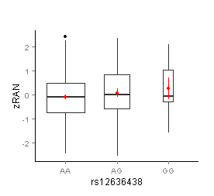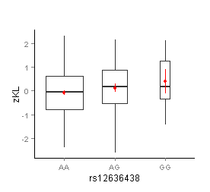

Figure S3: Rapid naming (zRAN) and phoneme awareness (zPA) scores in relation to rs7187223 genotypes for children and adults. The mean with the standard error per group shown in red.
Children
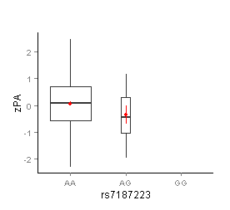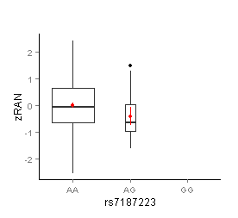
Adults
