**SUPPORTING INFORMATION**

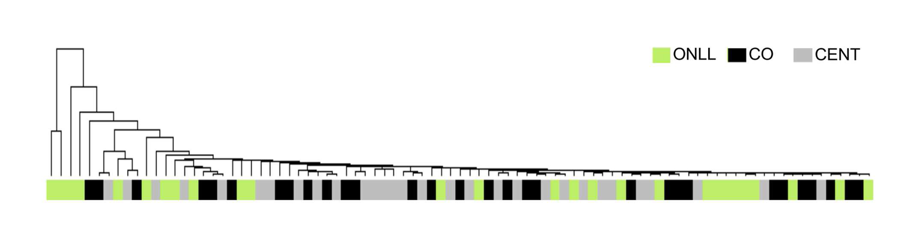

**Figure 1S. Unsupervised hierarchical clustering using heteroplasmy levels.** CENT: gray bar; CO: black bar; ONLL: green bar.

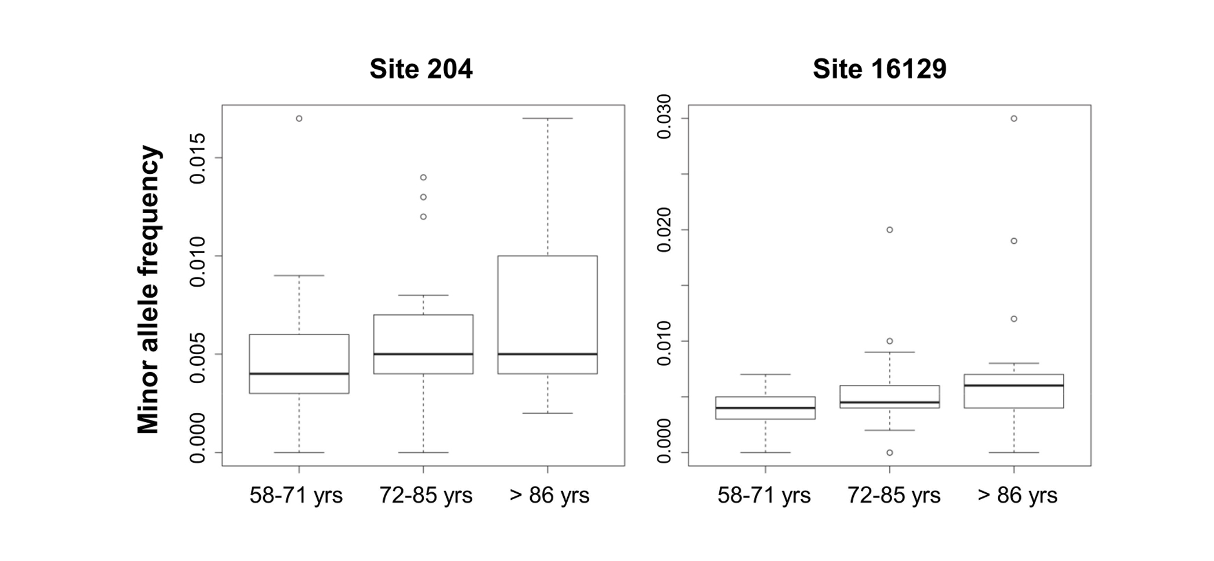

**Figure 2S. Boxplots of minor allele frequencies across 3 different age classes.** Age < 72 yrs; N=31, age range: 72-86 yrs; N=26 and age > 86 yrs; N=29 respectively for two heteroplasmic sites

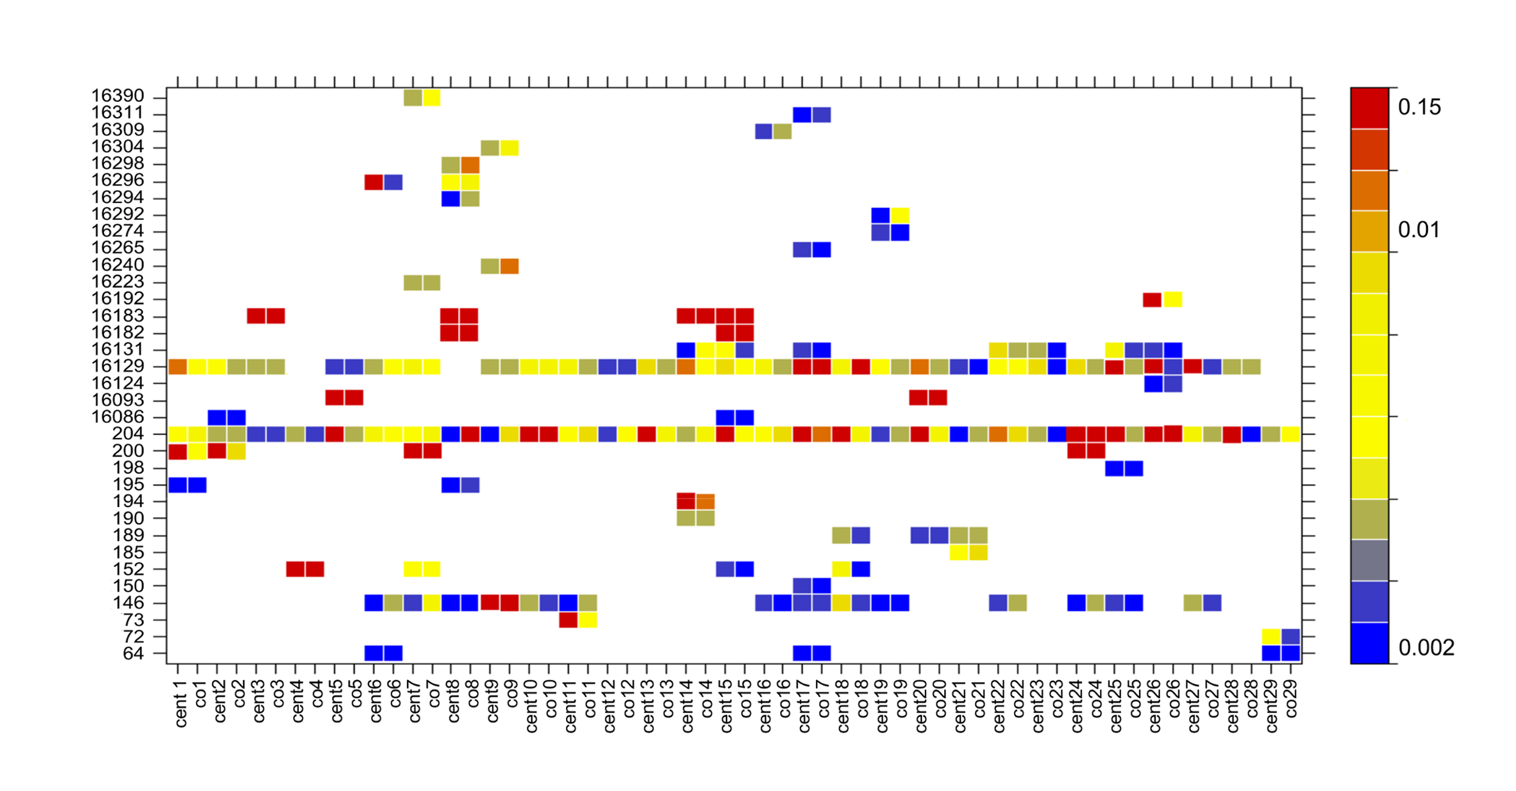

**Figure 3S. Heatplot of minor allele frequencies, colored according to the scale bar, for each mother-offspring pair.** Rows are positions and columns are individuals.

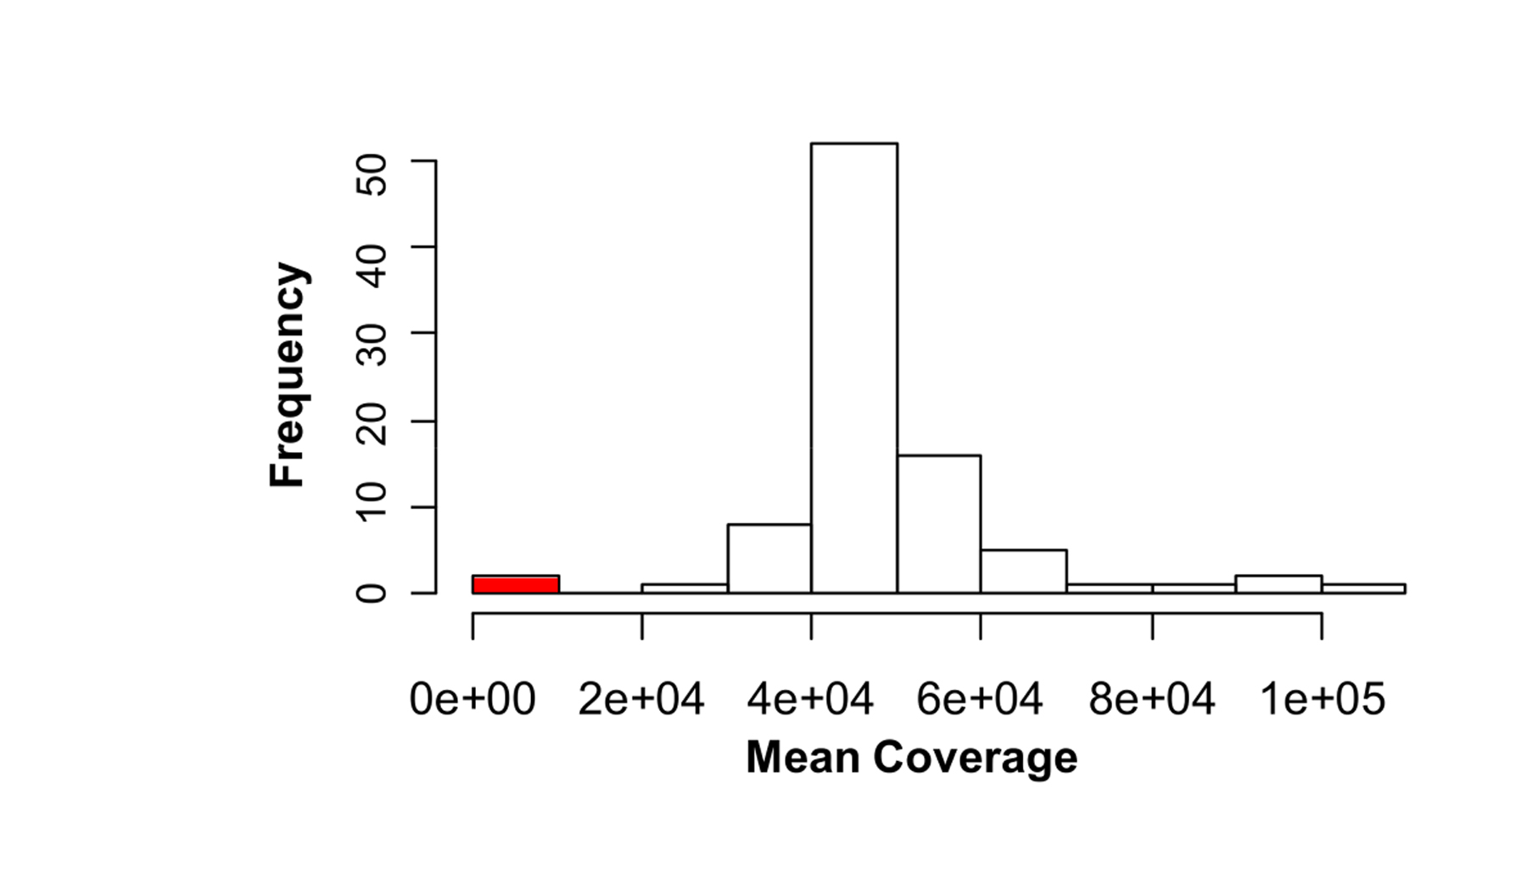

**Figure 4S. Mean coverage distribution.** Two samples with low coverage (indicated in red) were excluded from the analyses.

**Table 2S. List of common heteroplasmic positions in each CENT-CO pair.** Private heteroplasmic sites (*i.e*., not shared by other families) are marked in gray.

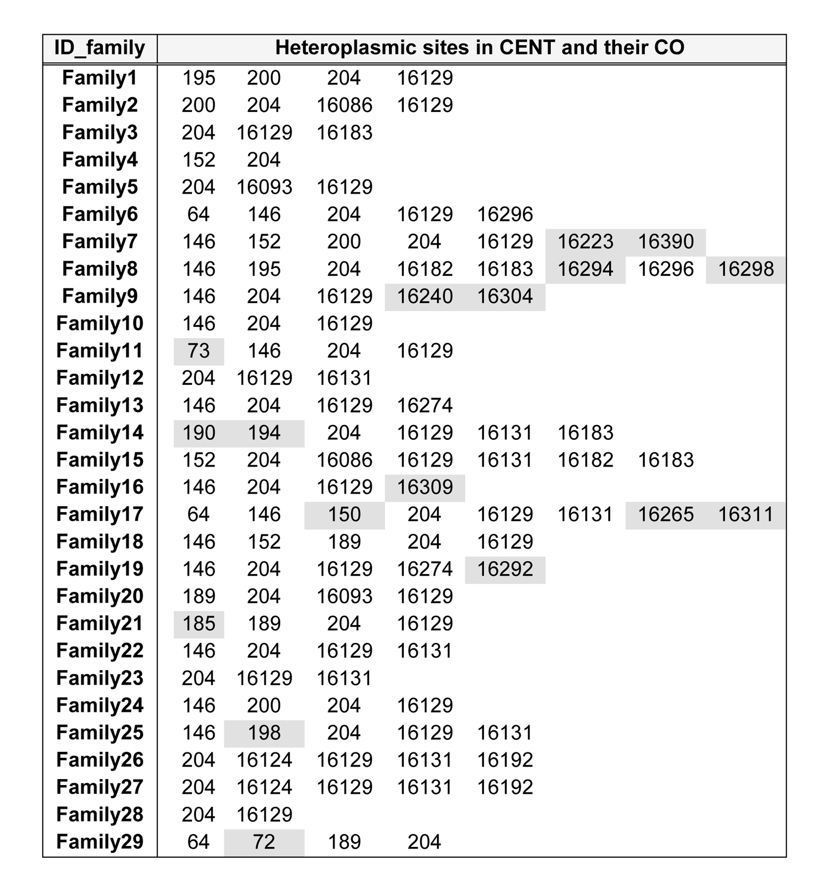

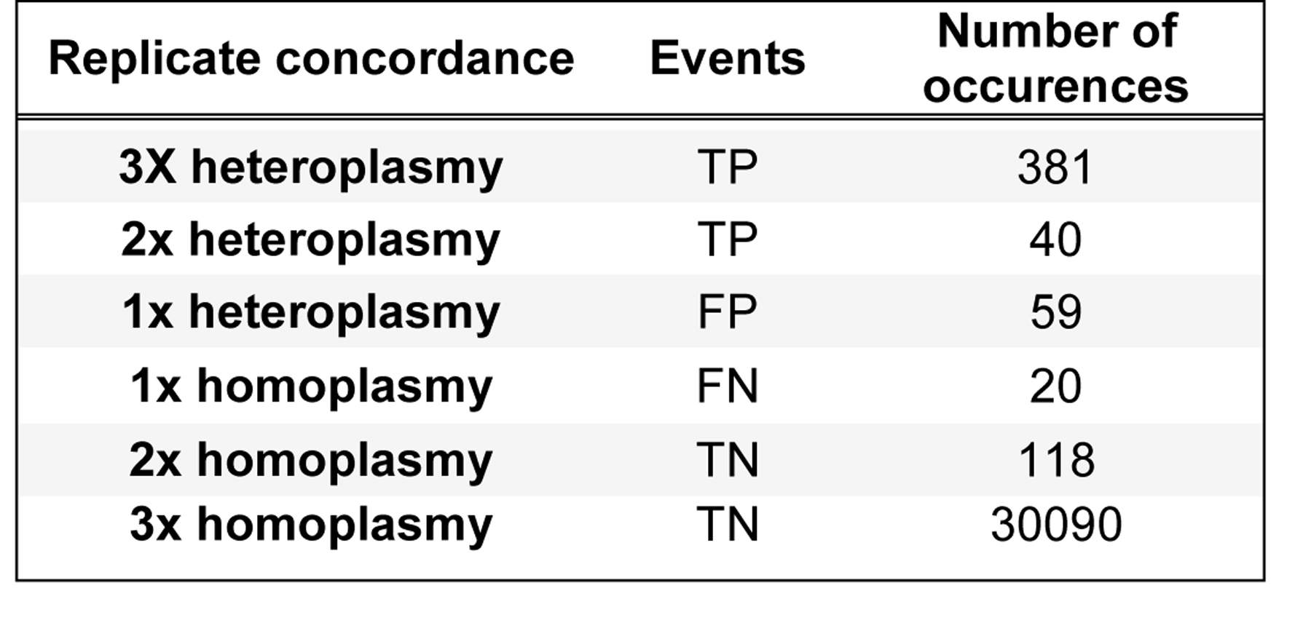

**Table 1S. Number of occurences observed for each possible outcome in the replicates.** TP: true positives, FP: false positives, FN: false negatives, TN: true negatives.